And I have a requirement like masking the ‘Tax_id’ column in AR.
In ‘Customer Maintenance’ Responsibility we have a form ‘Customer Maintenance’, In this we need to mask ‘Tax_id’ Column,

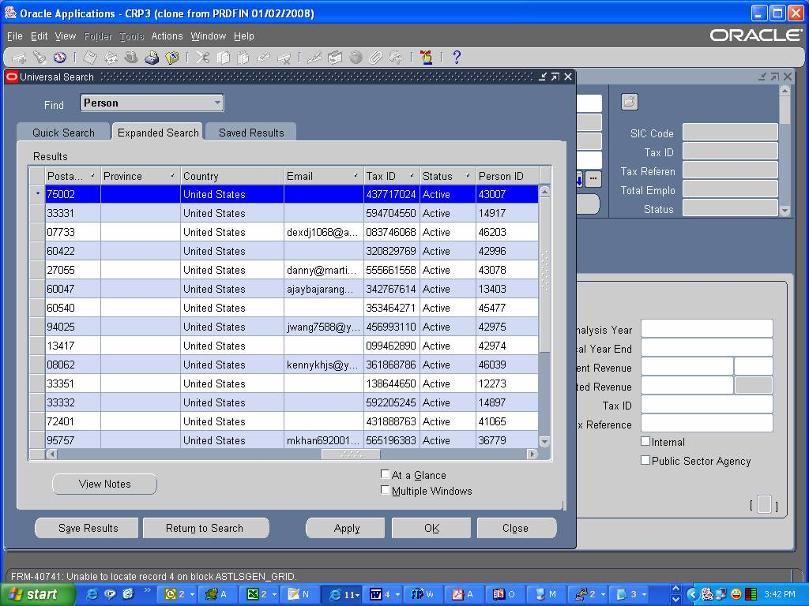

I need to mask/hide ‘Tax ID’ column which is displaying in the above form.
When I go to actual FMB I found that there is only one field in the required data block. ITEM_GRID of java bean type. I took the class file name implementation class. But I don’t know what to do next to hide this field?

Please provide the information for below questions.

- How we know the particular java ‘.class’ file is running for the particular Form/Block?
- Where we can find the actual java ‘.java’ files in the oracle server?

